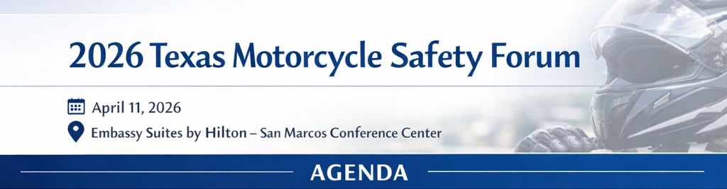
8:00 – 9:00 AM | Registration & Breakfast | Veramendi Pre-Function G – J
9:00 – 10:00 AM | Opening Session | Veramendi GH
- Welcome Remarks & Awards Presentation
  - Speaker(s): Cathy Brooks, Texas A&M Transportation Institute & Maurice Manness, Texas Motorcycle Safety Coalition
  - Description: Kick off the 2026 Motorcycle Safety Forum with opening remarks that set the stage for a shared commitment to saving lives on our roadways. This will be followed by the 2026 Motorcycle Safety Awards presentation, honoring outstanding individuals and organizations whose leadership, dedication, and impact have advanced motorcycle safety across Texas and beyond.
- Keynote Session Title: 30x30 — A Practical Path Toward Zero
  - Speaker: Eric Teoh, Insurance Institute for Highway Safety
  - Description: Roadway deaths in the U.S. have risen dramatically, even as many communities embraced Vision Zero. In this keynote, Eric Teoh introduces 30x30, a data-driven call to reduce traffic fatalities by 30% by 2030 through realistic, achievable actions. The session highlights how incremental policy, infrastructure, and vehicle safety improvements can save thousands of lives and put the nation back on track toward zero fatalities.
10:00 – 10:15 AM | Break & Networking
10:15 – 11:00 AM | Concurrent Sessions (Choose One)
Session A: Prehospital Blood Programs & Trauma Outcomes — Advancing Care for Motorcyclists and All Crash Victims | Veramendi I
- Speaker: Dr. C.J. Winckler, University of Texas Health Science Center at San Antonio
- Description: In this session, Dr. Winckler will discuss the vital role of prehospital blood programs in enhancing survival for patients with traumatic injuries — including motorcyclists — by enabling emergency medical teams to administer lifesaving blood products before hospital arrival. Attendees will learn how early blood intervention in the field can stabilize severe bleeding, reduce preventable deaths, and strengthen trauma care outcomes in the prehospital setting.

Session B: Enhancing Safety During Traffic Stops — Law Enforcement & Rider Perspectives | Veramendi GH
- Speaker(s): Kolby Musick & Maurice Maness, Texas Motorcycle Safety Coalition
- Description: This session brings together law enforcement and motorcycle rider experts to explore strategies for safe interactions during traffic stops. Discussion will include rider and officer perspectives, best practices for reducing risk, and related topics such as street racing and other rider–law enforcement encounters.
11:00 – 11:15 AM | Break & Networking
11:15 AM – 12:00 PM | General Session | Veramendi GH
- Session Title: Emerging Motorcycle Technologies: Enhancing Rider Safety and Future Standards
- Speaker: Dieter Weber, Robert Bosch LLC
- Description: This session will highlight advanced technologies being developed for motorcycles to improve rider safety, including features designed to prevent crashes and enhance rider awareness. The session will also explore emerging safety standards.
12:00 – 1:30 PM | Motorcycle Safety Luncheon | Veramendi GH
- Optional Event: Motorcycle Slow Race — Precision, Balance, and Skill on Two Wheels
  - Led by Daniel Hernandez, DBB Powersports
  - Location: North Parking Lot
1:30 – 2:15 PM | General Session | Veramendi GH
- Session Title: ADAS Testing with Motorcycles — Emerging Insights and Research
- Speaker: Eric Teoh, Insurance Institute for Highway Safety
- Description: In this session, Eric Teoh will share the latest research on how advanced driver assistance systems (ADAS) interact with motorcycles, highlighting detection challenges, real-world performance, and opportunities to prevent more crashes. The session will cover recent test-track findings and emerging strategies to improve crash avoidance technology for motorcycle riders.
2:15 – 2:30 PM | Break & Networking
2:30 – 3:15 PM | Concurrent Sessions (Choose One)
Session A: Gas, Rubber, and Risk: Understanding the Real Cost of Motorcycle Tires | Veramendi I
- Speaker: Daniel Hernandez, DBB Powersports
- Description: Motorcycle tires are a critical safety component, yet many riders underestimate both their cost and how quickly they wear during normal riding. Because this audience is already familiar with tire safety fundamentals, this session will focus on new ways to communicate the value of tires to newer riders. One practical comparison is fuel consumption. Every ride uses both gasoline and rubber, but riders usually only think about the cost they see at the pump. By reframing tires as a normal operating expense similar to fuel, instructors and safety professionals can help riders better understand tire replacement, plan for the real cost of riding, and avoid operating motorcycles on worn or aging tires.
Session B: Automated Vehicles & Motorcycle Safety | Veramendi GH
- Speaker: Bart Teeter, Bot Auto
- Description: Join Bart Teeter at Bot Auto for a forward-looking session on how autonomous vehicle technologies can improve roadway safety — including interactions with motorcycles and other vulnerable road users. Drawing on his extensive law enforcement and AV safety experience, Bart will explore practical strategies for deploying driverless commercial vehicles responsibly, minimizing human error, and enhancing detection and response around motorcycles and mixed traffic environments.

3:15 – 3:30 PM | Break & Networking
3:30 – 4:15 PM | General Session | Veramendi GH
- Session Title: Rider Education & Training in Texas
- Speaker: Shanisty Villanueva, Texas Department of Licensing and Regulation
- Description: This breakout session will provide an overview of the Texas Department of Licensing and Regulation (TDLR), with a focus on instructor requirements and the structure of the state’s motorcycle safety curriculum. Attendees will gain insight into how instructors are trained and certified, as well as the key components and standards that guide motorcycle education programs in Texas.
4:15 – 4:30 PM | Closing Remarks & Return Evaluations | Veramendi GH
- Speaker(s): Cathy Brooks, Texas A&M Transportation Institute & Maurice Manness, Texas Motorcycle Safety Coalition

Bios:
Daniel Hernandez, Owner, DBB Powersports
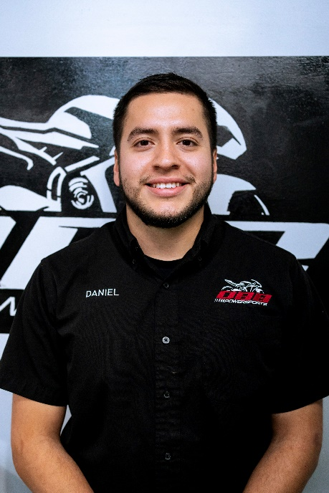
Daniel Hernandez is the owner of DBB Powersports, a motorcycle service shop in Central Texas. Through his work, he serves riders as a consultant first, helping them make informed decisions about maintenance, upgrades, and how to spend their money effectively to keep their motorcycles safe and performing properly. Having started riding at a young age, he developed a strong interest in maintaining and repairing motorcycles and has spent years working hands-on with riders across a wide range of experience levels. While his work covers many aspects of motorcycle ownership, this session focuses specifically on tire safety and helping riders better understand tire wear, replacement timing, and the real operating costs of riding.

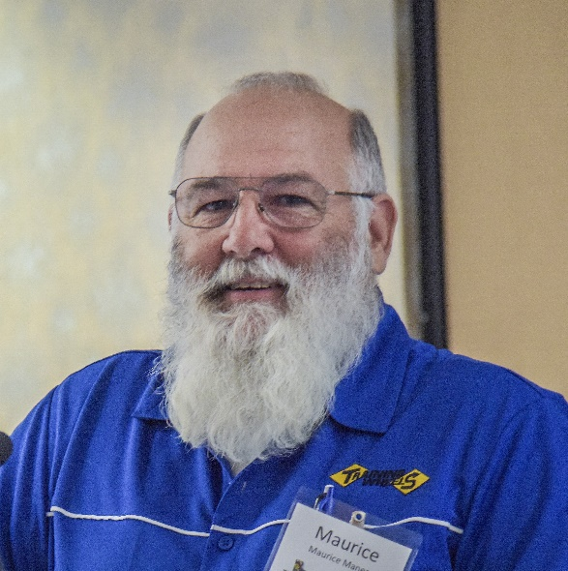
Maurice Maness, Owner, Training Wheels
Maurice Maness is a lifelong motorcycling enthusiast and founder of Training Wheels in College Station, Texas. A civil engineering graduate from Texas A&M University, Maurice became a certified motorcycle safety instructor after completing a Motorcycle Safety Foundation course. Since 1997, he and his wife, Melissa, have run Training Wheels as a TDLR-licensed site, offering rider education that emphasizes skill, safety, and risk awareness. Maurice also serves as the Chairperson of the Texas Motorcycle Safety Coalition, working to improve motorcycle safety across the state.

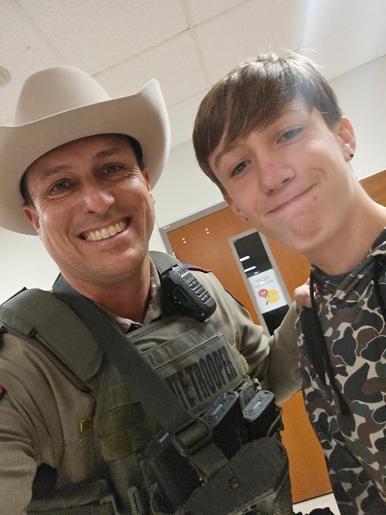
Kolby Musick, Sergeant, Texas Department of Public Safety
Kolby Musick is a Sergeant for the Texas Department of Public Safety, Highway Patrol Division. He has been with DPS for over 18 years and was in the Air Force for 4 years (2003-2007) prior to that. Kolby has over 20 years riding experience which includes 12 years on the Motor Unit with DPS. On the DPS Motor Unit he was a Master Instructor for the Department’s nationally recognized program in which he was a subject matter expert in helping to create. Kolby also attended the Motorcycle Safety Foundations, Rider Coach course to become an instructor. His current personal motorcycle is a Honda Africa Twin.

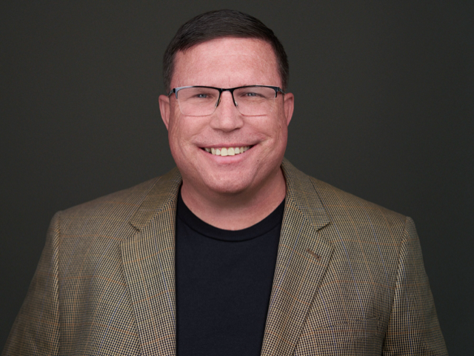
Bart Teeter, Director of Fleet and Operational Safety, Bot Auto
Bart Teeter is a respected professional in transportation safety and technology, currently serving as Director of Fleet and Operational Safety at Bot Auto in Houston, TX. His experience includes a career as a Captain in the Texas Highway Patrol, where he specialized in commercial vehicle enforcement and autonomous vehicle integration. He contributes to industry discussions through his participation in the AVIA First Responder Advisory Board, and has also served in leadership roles with the Texas Connected and Automated Vehicle Task Force and the Commercial Vehicle Safety Alliance. Bart’s background includes 23 years of service as a cryptologic linguist in the US Army and Air Force Reserve, with deployments to South Korea and Iraq. This experience adds a unique dimension to his understanding of complex operational environments.
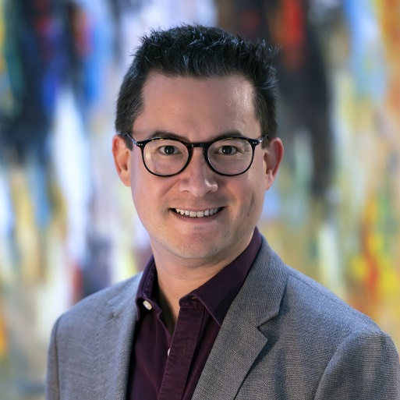
Eric Teoh, Director of Statistical Services, Insurance Institute for Highway Safety
Eric Teoh is Director of Statistical Services at the Insurance Institute for Highway Safety, where he has spent 20 years studying effective ways to reduce harm from crashes on our nation’s roads, including fatalities, injuries, and property damage. He ensures the statistical rigor of the Institute’s work, conducts and oversees research, and has authored numerous publications on topics such as motorcycle safety, crashworthiness, and technologies for crash avoidance and driving automation, and commercial vehicle safety. Additionally, he communicates key research findings to a variety of audiences through conferences, media appearances, regulatory submissions, and partnerships. He holds bachelor’s and master’s degrees in mathematics from the University of Alabama at Birmingham.
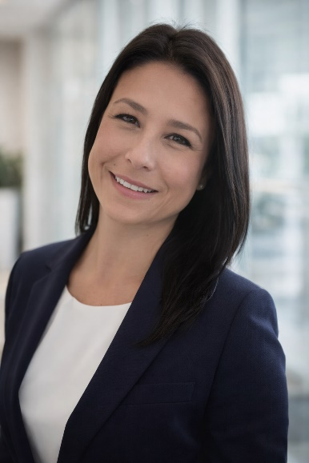
Shanisty Villanueva, Team Lead – Education & Examination Division, Texas Department of Licensing and Regulation
Shanisty Villanueva serves as a Team Lead in the Education and Examination Division at the Texas Department of Licensing and Regulation (TDLR), where she brings nearly 17 years of experience. She and her team played a key role in implementing Senate Bill 616, which transferred the Motorcycle and ATV Program from the Texas Department of Public Safety to TDLR in 2020.

Dieter Weber, Sales & Acquisition Manager – Two-Wheeler & Powersports, Robert Bosch LLC
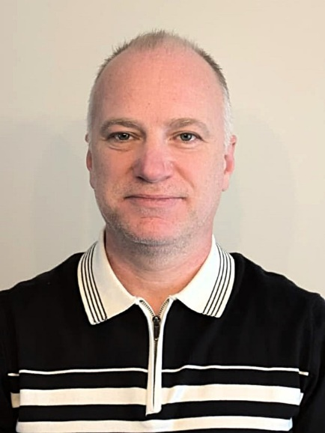
Dieter Weber, born in 1976 in Hermannstadt, Romania, relocated to Heilbronn, Germany in 1989 and later earned a degree in Mechanical Engineering (Dipl.-Ing. (FH)) from Heilbronn University. He began his career with Bosch in 2002 as a Design Engineer and advanced to Team Lead for Radar Hardware Mechanics and Vehicle Integration in Leonberg, Germany. From 2013 to 2017, he served as an expatriate Mechanical Expert supporting North American airbag programs in Plymouth, Michigan. He went on to hold roles as Product Component Manager and Engineering Manager for ADAS/ARAS customer projects from 2017 to 2025. Since 2025, he has led sales and acquisition efforts for two-wheeler and powersports systems at Bosch in Farmington Hills, Michigan.

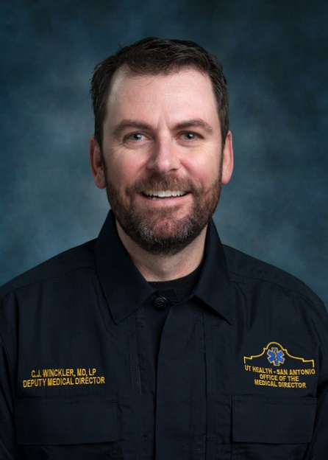
C.J. Winckler, Associate Clinical Professor, University of Texas Health Science Center at San Antonio
C. J. Winckler serves as the Deputy Medical Director for the San Antonio Fire Department and Medical Director for North Channel EMS and Wilson County ESD 3. He is also the Texas Emergency Medical Task Force Region 8 Medical Director. Dr. Winckler is an Associate Professor at the University of Texas Health Science Center at San Antonio and the Texas A&M College of Medicine. He is the President of TX NAEMSP, Chair of the GETAC EMS Medical Directors Committee, and Vice Chair of the GETAC Prehospital Whole Blood Task Force. Dr. Winckler provides daily clinical supervision—through on-scene and online medical direction, as well as performance improvement processes—to more than 2,000 EMS providers. In San Antonio, he has developed telemedicine CPR for dispatch, an ECMO prehospital CPR alert system, and the world’s first prehospital whole blood program serving an entire metropolitan system.

Evaluation QR Code:
We value your feedback! Scan to submit your evaluation.



